Exercise 1
- The log-likelihood test suggest there are significant differences between male and female (p = .043).
The plot of nonparametric estimate of the survival function shows that the curves for male and female are not that different, and their CLs overlap.
The log-likelihood test and the nonparametric approach draw different conclusions on whether there are significant differences between male and female. I think this is because when using log-likelihood test, we assume that the survival function of each gender follows an exponential distribution, while the nonparametric approaches use a variety of weighting schemes.

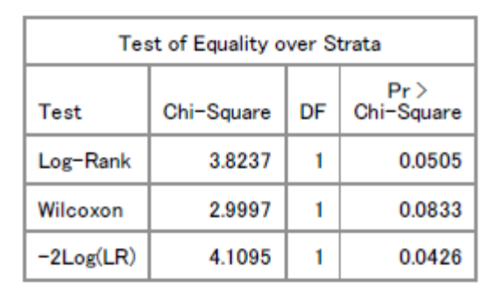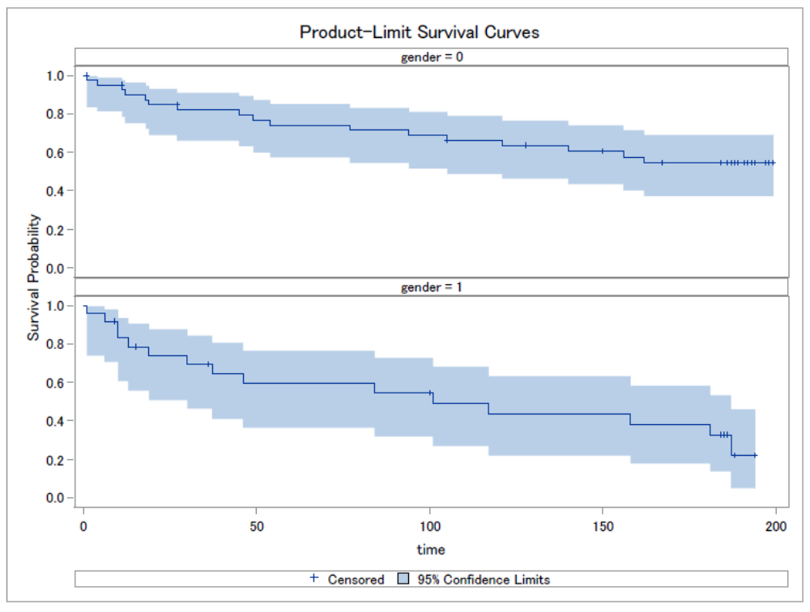

- As shown in the tables below, the AIC is 238.82 without covariates and 210.75 with covariates.
Parameter estimates:
- BMI: 1.099, meaning that a one unit increase in body mass index leads to a 9.9% increase in the likelihood of dying before medical event. 95% CI (1.022, 1.181).
- Age: 1.061, meaning that a one unit increase in age leads to a 6.1% increase in the likelihood of dying before medical event. 95% CI (1.035, 1.088).
- Gender: 1.360, which means that female patients are 36% more likely to die before medical event, compared with male patients. 95% CI (0.646, 2.863).

The effect of gender is not significant (p = .65), but the effects of bmi (p = .011) and age (p < .0001) are significant.

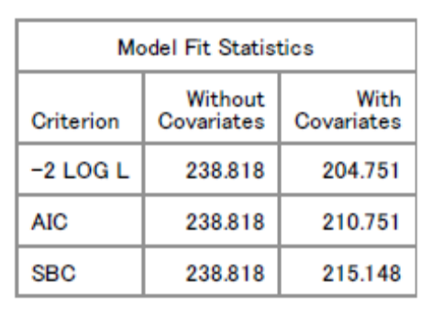
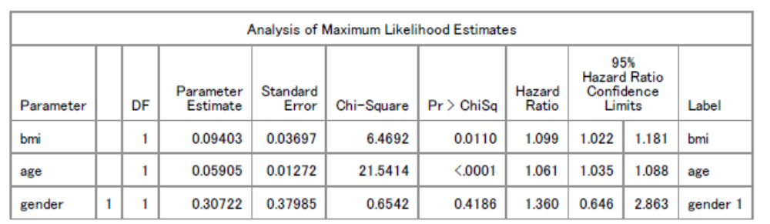

- Because age, bmi and time change on very different scales, it makes more sense to talk about changes in standard deviation units.
AIC: the same as we got in b. 238.82 without covariates, and 210.75 with covariates.
Parameter estimates:
- BMI: hazard ratio 1.655, meaning that a one standard deviation increase in body mass index leads to 65.6% increase in the likelihood of dying before medical event. 95% CI (1.122, 2.44).
- Age: 1.061, which means that a one unit increase in age leads to a 6.1% increase in the likelihood of dying before medical event (same as in b). 95% CI (1.035, 1.088).
- Gender: 1.360, which means that female patients are 36% more likely to die before medical event, compared with male patients (same as in b). 95% CI (0.646, 2.863).

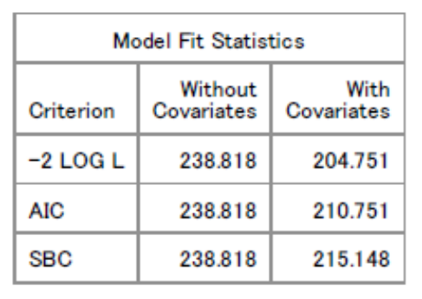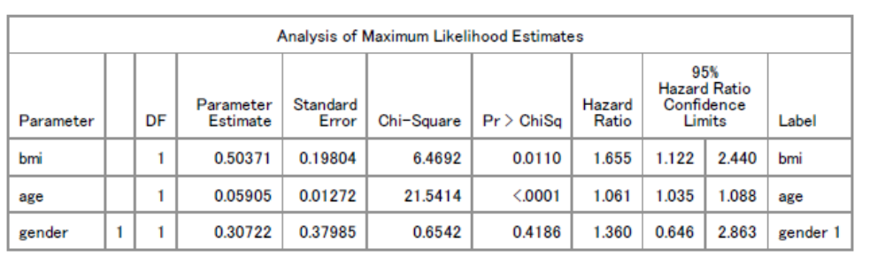
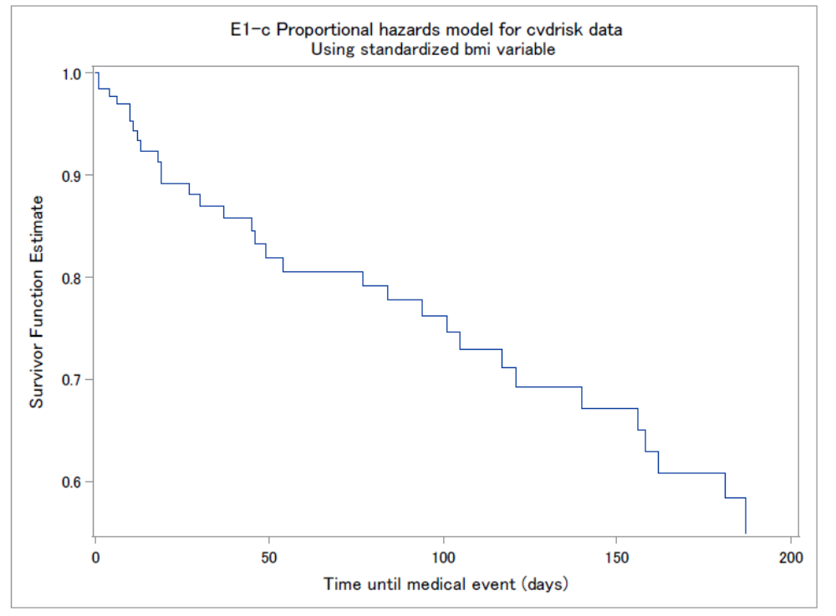

Exercise 2

- As shown in the table below, length, weight, speed and diet have very different scales (length is under 10, speed and diet range from 13 and 0 to 3 digits, while weight ranges from under 0.02 to 7000), and therefore, it will be more appropriate to fit a PCA model to the correlation matrix.
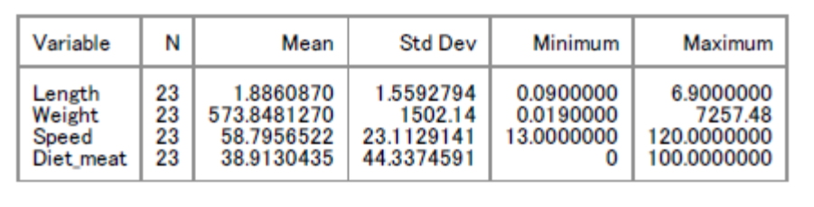

- Eigenvalues and eigenvectors are shown in the tables below, and approximately 80% variation is explained by the first two components.
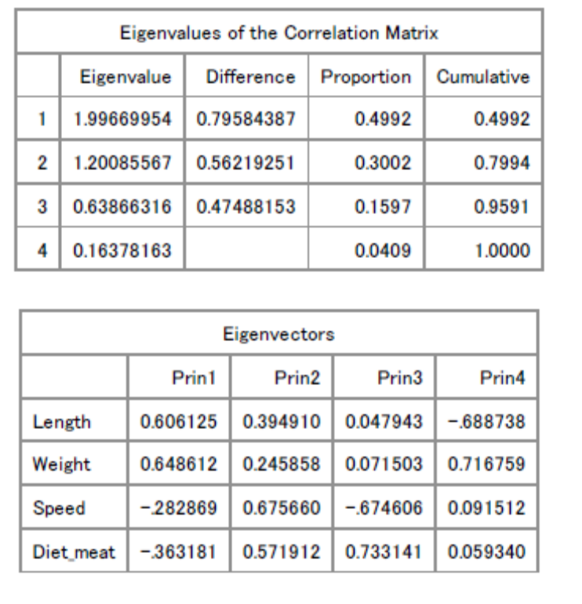

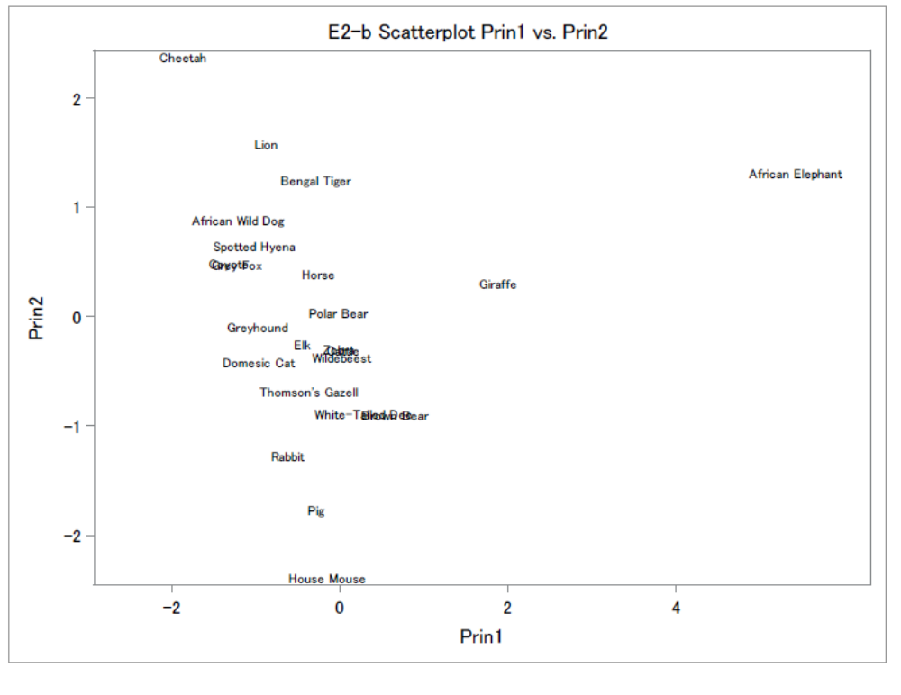
Form the scatterplot above and the data we have, principal component 2 might have to do with speed, because the rank of speed obtained from the plot share the pattern to some extend with the rank of speed in the data (e.g., cheetah, the fastest in the data also has the highest value on prin2). However, there are still patterns that do not match; for example, African wild dog is faster than Bengal tiger and African elephant, but it has lower values on prin2 compared with those two animals. Prin 1 is even harder to interpret, because the pattern does not match well with that of any variable, according to the data.

- As shown in the table below, the factor loadings on factor 1 of the 4 variables are .96 for length, .94 for weight, -.01 for speed, and -.16 for diet, and factor loadings on factor 2 of the 4 variables are -.015 for length, -.19 for weight, .84 for speed, and .79 for diet. Variance explained by factor 1 is 1.82, and by factor 2 is 1.37.

The rotation did make the interpretation easier, and we can tell from the plot that factor 1 is probably closely related to length and weight, because animals with higher length and weight tend to place higher on factor 1 (e.g., African elephant, the heaviest is by itself on the right end of factor 1 axis, and Giraffe, the second longest and heaviest, is to the elephant’s left but still to all other smaller animals right; house mouse, the shortest and lightest on the left end of factor 1 axis). Therefore, perhaps we can call factor 1 “size”.

Factor 2, however, is probably more about speed and diet (theses 2 variables should be related for most animals anyway). For example, cheetah, the fastest animal in the data, only eats meat, and is placed by itself at the very top of factor 2 axis. African elephant, which eats no meat and has a relatively low speed, has a negative factor score on factor 2. Giraffe eats no meat either, but is slightly faster than African elephant, and thus is located a little bit higher on factor 2 axis than elephant. Lion is fast, and eats only meat, so it’s also pretty high on factor 2. Therefore, factor 2 probably can be named something like “living features”.

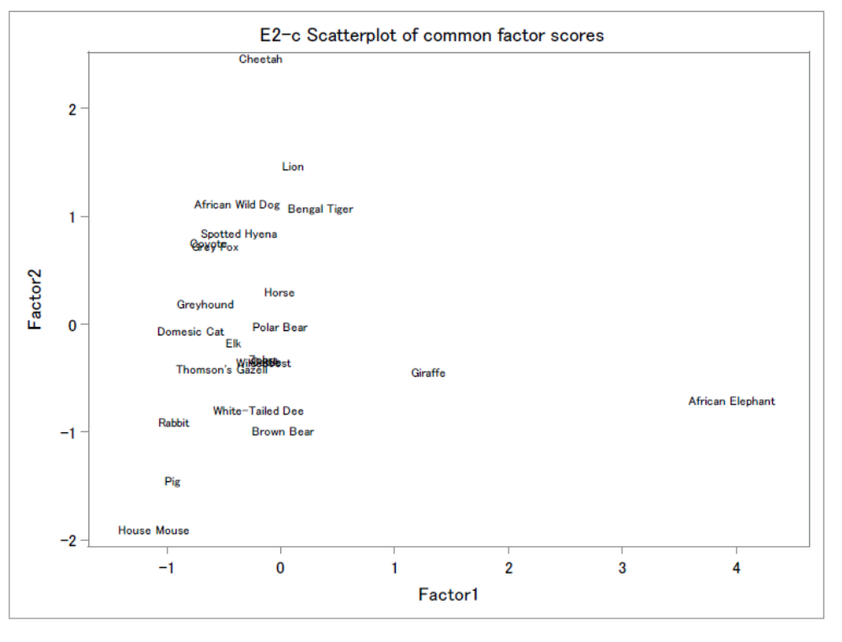
Exercise 3
- According to the dendrogram below,
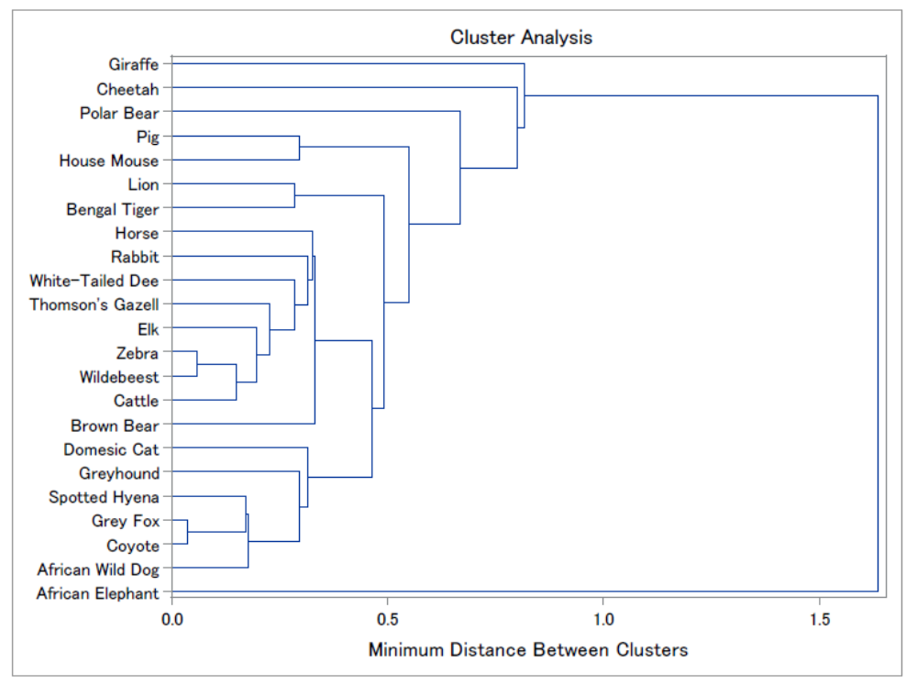

- According to the tree below,
